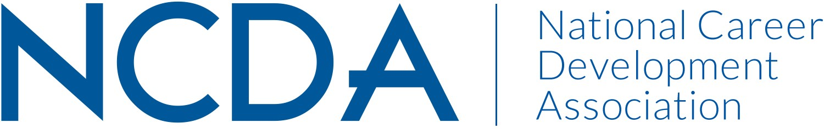

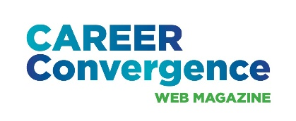
NCDA ANNUAL REPORT

CAREER CONVERGENCE WEB MAGAZINE
September 9, 2025

Editor: Melanie Reinersman, webeditor@ncda.org
Associate Editors: Natasha Barnes, Brittany Collins, David Dietrich, Jane Frisch, Candina Janicki, Vonya Hodrick, Maisie Lynch, Jill Minor, Meredith Montgomery, Elyse Pipitone, Billie Streufert
Field Editors: Mason Murphy, Willa Smith, Regina Gavin Williams

Committee Activities to Date

- Published new issues on the first of each month (except Jan.) bringing the total issues up to 233, since 2003 (Strategic Goal #2- Career Empowerment: Publications)
- Published 7 new articles, plus one Tech Tip, each month. Electronic distribution to over 28,000 emails on the first of the month and over 1700 articles archived
- Investigated and achieved Board approval for new auditory player plug-in, so articles posted April 2025 and after can be played anytime (Strategic Goal #1- Community: Engagement)
  - Avg monthly clicks: 150; Highest Clicks: 197 (June); July lowest
- Achieved record-high hit rates for articles related to retirement, theory, and Gen Z (Strategic Goal #2- Career Empowerment: Publications)
- Held virtual call with editorial team on December 18, 2024 and live meeting on June 19, 2025 at conference (Strategic Goal #1- Community: Engagement)
- Considered Multiview’s offer to place advertisements in web magazine (Strategic Goal #1- Community: Create new networking opportunities)
- Noted 2 Associate Editors & 1 Field Editor resignation; on-boarded 1 new Assoc. Ed. and 1 new Field Ed. (Strategic Goal #1- Community: Engagement)
- Selected winner (by editors’ votes) the annual “Career Convergence Recognition Award” – Allison Levine, winner (Strategic Goal #1- Community: Engagement)
- Published articles in cooperation with NCDA committees, e.g., GCC, LA & NCD month (Strategic Goal #1- Community: Engagement)
- Social media each month handled by NCDA Social Media coordinator, with links to the issue and each article, increasing hit rates (Strategic Goal #1- Community: Recruitment)

Projected Plan/Work Planned to be Completed through September 30.

- Continue to publish monthly issues of the web magazine
- Consider Multiview’s offer to place advertisements in web magazine

