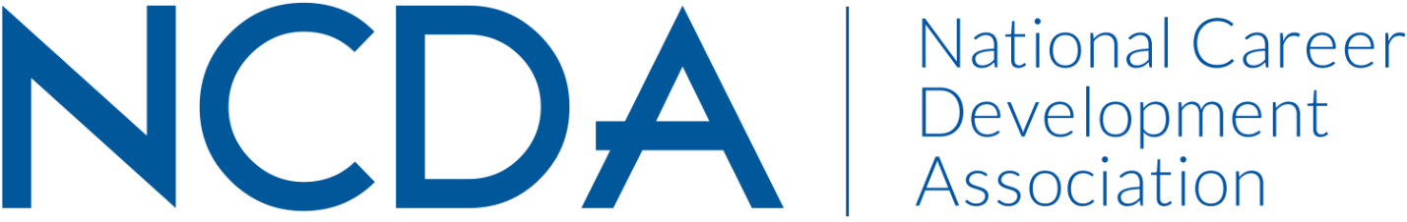

Annual Report

MEMBERSHIP COMMITTEE
September 4, 2024

Committee Co-Chairs:
- Dr. Mary Edwin (edwinmo@umsl.edu)
- Dr. Heather Robertson (robertsh@stjohns.edu)
List Committee Members (no contact information required)
- Emily Gomez (egomez@hireheroesusa.org)

Activities to Date
Since mid-year report:
- Received contact from two new members with interest in NCDA Membership Committee: Kimberly Carothers and Delasia Rice; included in 8/24/2024 meeting
- Conducted a NCDA Membership Committee Meeting on August 27, 20224, with plans to continue membership drive in 2025 and meet with NCDA liaison to review prior membership committee idea and efforts

Projected Plan through fiscal year end (September 30th)

- Co-chairs to meet with NCDA liaison to review prior ideas and efforts
- Schedule another meeting of NCDA membership committee for fall 2024

If you received funding for your work, what specific outcome(s) benefited NCDA? N/A – no funding received

